Practice Challenge
LO4 - Realizing
Malamski,Dimitar D.S.
mitemalamata@gmail.com

Contents
Introduction 2
Sprints 2
Sprint 1 2
Sprint 2 2
Evidence 1 - Preparing the dataset for model training 2
Evidence 2 - Preprocessing categorical features for model training 3
Evidence 3 - Applying train/test split and feature scaling 5
Evidence 4 - Validating models using industry-standard evaluation metrics 6

Introduction
This document presents the evidence for Learning Outcome 4 ( Realizing ) in my Practice Challenge project - Student Dropout Prediction. The purpose of this document is to show how I demonstrated this learning outcome by preparing and preprocessing data, applying machine learning techniques, and validating model performance using industry-standard evaluation metrics. The evidence is organized by sprint, with each section describing the activity, the result, and why it is relevant to the learning outcome.

Sprints

Sprint 1
There was no progress made relating to Realizing during Sprint 1.

Sprint 2

Evidence 1 - Preparing the dataset for model training
What this evidence is
This evidence shows how I prepared the dataset so it would be suitable for machine learning.
What I did
I cleaned the column names, checked the dataset for missing values, and ensured that the target variable was represented consistently. I also removed records that were not suitable for final prediction modelling and prepared the dataset in a format that could be used for further preprocessing and training.
Result
The dataset became cleaner, more consistent, and suitable for the next technical steps in the machine learning pipeline.
Why this is relevant to the Learning Outcome
This demonstrates realizing because I prepared the data according to quality criteria and made it suitable for analysis and model training in a transparent and repeatable way.
Attached evidence
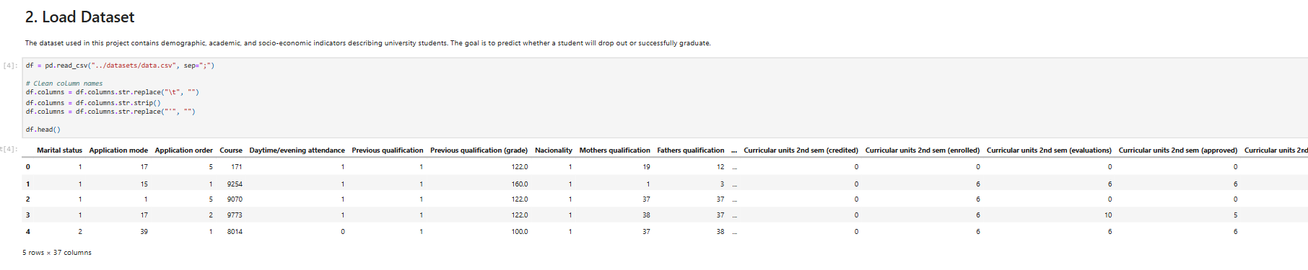
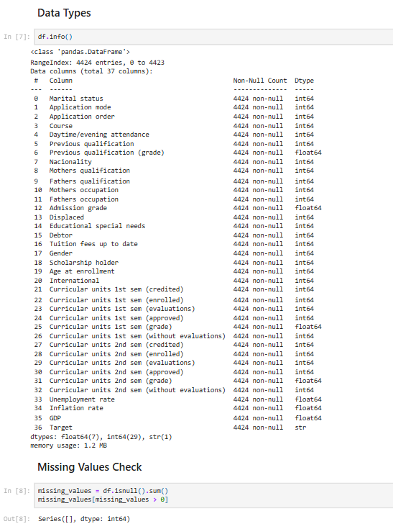

Evidence 2 - Preprocessing categorical features for model training
What this evidence is
This evidence shows how I transformed categorical variables into a format that machine learning models could use effectively.
What I did
I identified categorical variables that were encoded as integers but did not represent true numerical relationships. I then reduced high-cardinality categories by grouping less frequent values into an Other category and applied one-hot encoding to convert categorical variables into binary features.
Result
This preprocessing step reduced unnecessary dimensionality and ensured that the models would not incorrectly interpret categorical codes as ordinal numerical values. The resulting dataset became more suitable for machine learning.
Why this is relevant to the Learning Outcome
This demonstrates realizing because I applied systematic preprocessing methods, including grouping and encoding, to transform raw data into a format appropriate for model training.
Attached evidence
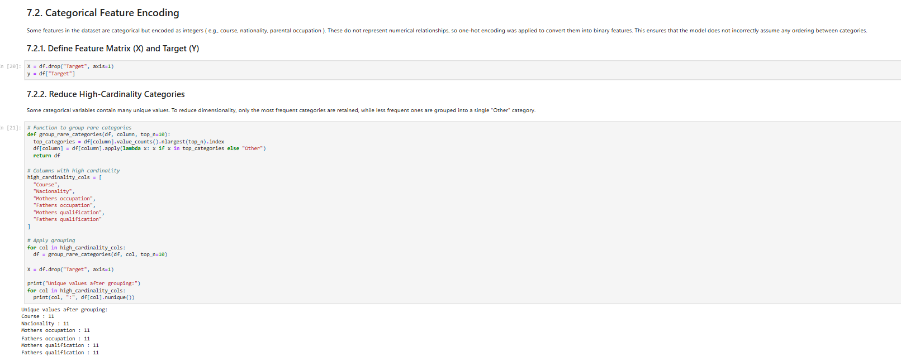
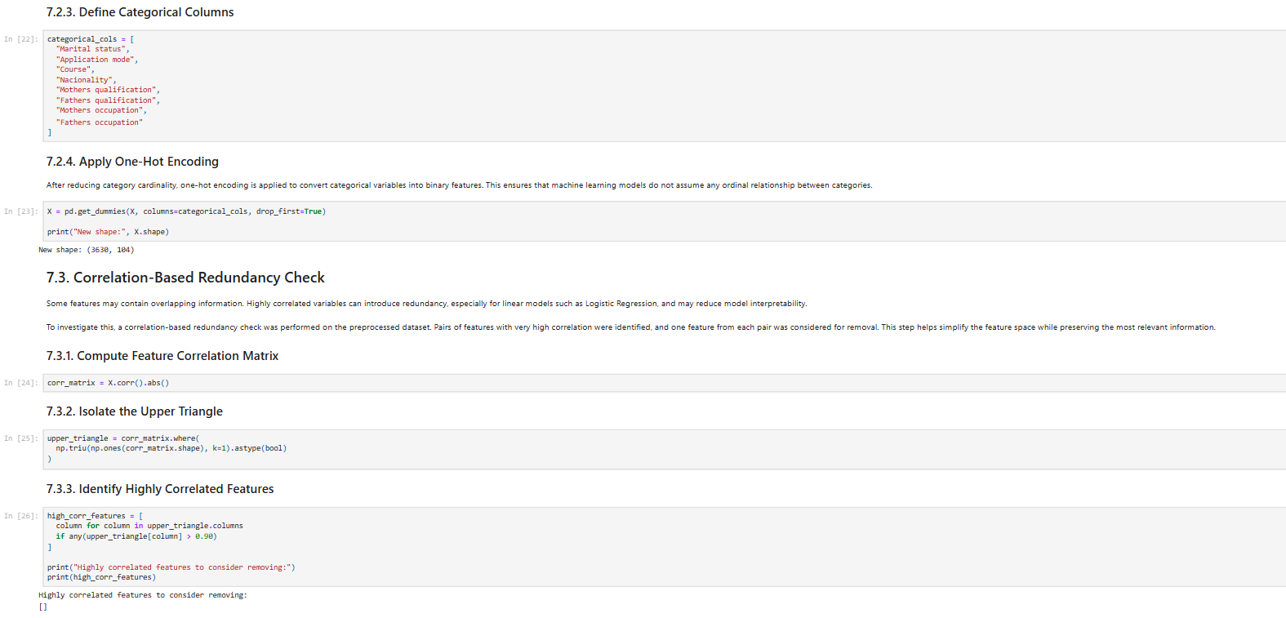
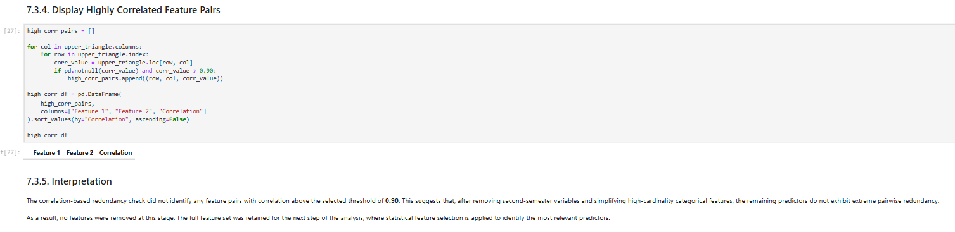

Evidence 3 - Applying train/test split and feature scaling
What this evidence is
This evidence shows how I prepared the feature data for machine learning experiments through splitting and scaling.
What I did
I separated the dataset into feature variables and target labels, then applied a stratified train/test split to ensure comparable class distributions between training and testing sets. After this, I used StandardScaler to scale the features for models that are sensitive to feature magnitude, such as Logistic Regression.
Result
This created a fair and technically appropriate setup for model training and evaluation. The split preserved class balance, and scaling ensured that the models could learn from the data more effectively.
Why this is relevant to the Learning Outcome
This demonstrates realizing because I used standard preprocessing techniques to make the dataset suitable for model training and evaluation in a repeatable and technically sound way.
Attached evidence
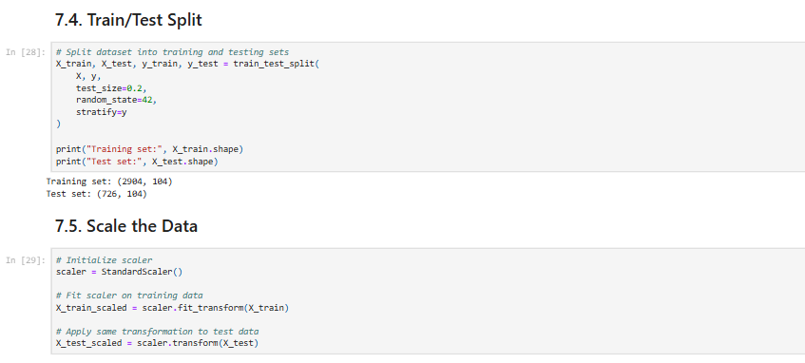

Evidence 4 - Validating models using industry-standard evaluation metrics
What this evidence is
This evidence shows how I validated the trained models using commonly accepted machine learning evaluation methods.
What I did
I evaluated the models using accuracy, precision, recall, F1-score, ROC-AUC, confusion matrices, ROC curves, and cross-validation. I applied these metrics consistently across the different models so that their performance could be judged in a structured and comparable way.
Result
This validation process made it possible to determine how well each model performed and how suitable it was for identifying students at risk of dropping out.
Why this is relevant to the Learning Outcome
This demonstrates realizing because I validated the models against industry-standard evaluation metrics and used a transparent evaluation process to assess model performance.
Attached evidence
